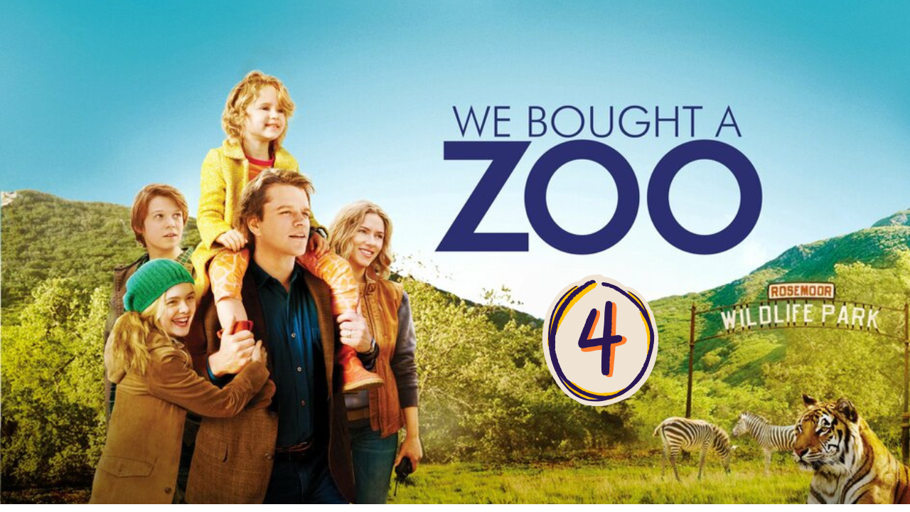
“We Bought a ZOO” (Scene 04)

Part 01 / Work on the Scene

- Scene summary:

The scene begins when Mr. Mee is talking about the situation of the zoo. However, he isn’t convinced, but in the end he makes the deal because Rosie loves the place. His brother doesn’t agree with him and advises him to renounce the idea. Moreover, his son is upset too. At the end of the scene, Mr. Mee and his daughter are tidying their clothes to move to their new house.

- Scene Discussion & Analysis:

- Q01: Why can’t Benjamin buy the property without having to buy the entire ZOO?
Benjamin can’t by the property without having to bay the entire ZOO because they can’t be separated.
- Q02: Did he agree to make the deal initially?
No, he didn’t.
- Q03: What made him change his mind all of a sudden?
He changed his mind because Rosie loves the place.
- Q04: How about Benjamin’s older brother? How did he receive the idea?
Benjamin’s brother didn’t accept the idea of baying a zoo.
- Q05: Was his son Dylan as happy about the new ZOO-house as Rosie was? And did his attitude affect his father’s decision?
Dylan was upset about the new zoo-house. nevertheless his position didn’t affect the final father’s decision.

Part 02 / Acquired vocabulary & Grammar from the scene
- Acquired Vocabulary (OPTIONAL):
- Stipulation:A stipulation is a condition or requirement that is officially stated or agreed upon, especially in a contract, deal, or discussion.
- Example in a sentence:
“ The job offer came with a stipulation that he must work at least two years before applying for promotion.”
- Broken-down (adj):
- Example in a sentence:
“ Buildings in Gaza were completely broken-down.”
- Psyched (adj):“Psyched” is an informal (slang) word that means excited, mentally prepared, or motivated for something.
- Example in a sentence:
“ He psyched himself up before the big game. .”
- Irregular Verbs:

Infinitive | Past simple | Past participle
To shut down | Shut down | Shut down
To keep up | Kept up | Kept up
To buy | bought | bought
To eat | ate | eaten
To wake | woke | waken
To wear | wore | worn

Part 03 / TRANSCRIPTION: improve your listening (Optional)

Task: Transcribe sentences from the scene.

- Transcribe Sentence 01
- What actually is steal a property with estabilashion I want to couple on board and that is the property. You have to care and maintain danger animals
- Transcribe Sentence 02
- I wanna quit my job, and tray something completely different with my life. But when they wake up another day and they saying them self’s thanks god my older brother didn’t let me blood death in herenance
- Transcribe Sentence 03
I don’t look too zebras and a lion and a jaguar and forty seven other spices. Seven which are dangerous and all of them are save . The secound we make this deal. The kids can be so exceted
- ... .... ..... ..... ..... ..... ... .... ..... ..... ..... ..... ... .... ..... ..... ..... ..... ... .... ..... ..... ..... ..... ... .... ..... ..... ..... ... .... ..... ..... ..... ..... ... ..... ... .... ..... ..... ..... ..... ... ..... ... .... ..... ..... ..... ..... ... ..... ...

Open discussion (OQ)
\
- Topic of discussion: It’s obvious that Rosie (Benjamin’s daughter) has influenced his decision to buy the ZOO. Do you think families should involve their children in such big decisions that affect all family members? And do you think Benjamin is playing a good role as a father? Does he seem to love and appreciate his two kids equally? If not, why do some parents prefer some of their children over the rest? And do they have the right to do so? (in your opinion) and how will that affect their children’s lives?
(Students are free to participate and interact to share their own opinions.)
(Students are encouraged to prepare their arguments before the session.)
In my opinion, children shouldn’t be directly involved in such big decisions because of their lack of life experience. Moreover, if we want to include them, we have to enable every member to participate. In this way, we can make sure that no one feels ignored. Unfortunately, however, parents tend to prefer some of their children over others for many reasons — maybe because they are smart, kind, or polite, etc. But this is not fair.

